EAST TIMOR UPDATE
Bulletin of the Peter Trust
- Registered Charity No. 1080159 -
AUTUMN 2010

East Timor inaugurates
Youth Parliament

“As day breaks in Dare ‘suco’ (village) a jovial Roque Santiago Braga De Araujo, 15, cannot wait to make the 45 minute bumpy road trip down the hill to the capital of East Timor, Dili.

This is the day Roque has been waiting for and he is not alone. Together with some 130 fellow young people who have been staying in RC church premises in Dare during the week, he is being inaugurated into East Timor’s pioneer Youth Parliament.

Rising out of chaos

The Youth Parliamentarians were identified by a rigorous selection process undertaken in over 440 ‘sucos’ country-wide. Each sub-district selected two young people aged between the ages of 12 and 17. The Youth Parliament process is based on the Council of Ministers’ Resolution in November 2009 which endorsed the parliament’s establishment and made it a unique youth participation platform in Timor-Leste (as the country is now called). In a conflict-devastated territory where 50% of the population is under 21 (!) it is an important step.

‘I’m so happy’ said Roque, ‘Three years ago we were in a difficult situation, the whole country was in chaos. Today we show that young people are ready to build the nation’.

Youth Participation

The inauguration, filled with pomp and glamour by various youth presentations (music, drama, speeches), was attended by youth, international development partners, and Government officials.

‘It has been a very exciting process for me and for UNICEF as we see Timor-Leste’s leaders creating an institution that will ensure voices of youth are heard and youth participate in developing and uniting the country’ said UNICEF Representative in TL Jun Kukita.
‘I’m happy that my parents were able to come and witness this occasion’ said one young Parliamentarian, Umbelina Concecao Alves Oliveirra, 17. ‘They can see that girls too can be leaders’.

Preparing to lead

‘This is an opportunity for you to learn and prepare to take leadership said President of the Democratic Republic of Timor-Leste Jose Ramos Horta as the young Parliamentarians visited his office.

The Youth Parliament will provide Timorese youth with a chance to have their voices heard in local community and national decision-making processes and will provide them with various leadership opportunities. It is supported by UNICEF and the Timor Leste Secretary of State for Youth and Sport.”
[Taken from an account for UNICEF written by Jairus Ligoo, disseminated on the email East Timor List facilitated by ETAN, 1.9.10]

The Peter Trust supports many
Projects for Youth

Responding to the evident need in Timor Leste for the training of Young People in leadership the Peter Trust has given support to the development of various facilities to enable this to progress.

Student Hostel in Dili

The Bom Samaritino - Good Samaritan - Hostel (established by Dili Diocesan Priest Fr Domingos Soares and located in the township of Gleno 40 miles south of the capital) needed help to ensure the continuation of the leadership training undertaken there for young people aged 12-16 when they then go on to attend St Paul’s High School in Dili. The Lar de Estudantes Santo Inacio de Loyola, built to accommodate fifty young people aged 16+, boys and girls, was in need of refurbishment and improvement to the dormitories, kitchen, study areas and toilets, and for roof repairs.

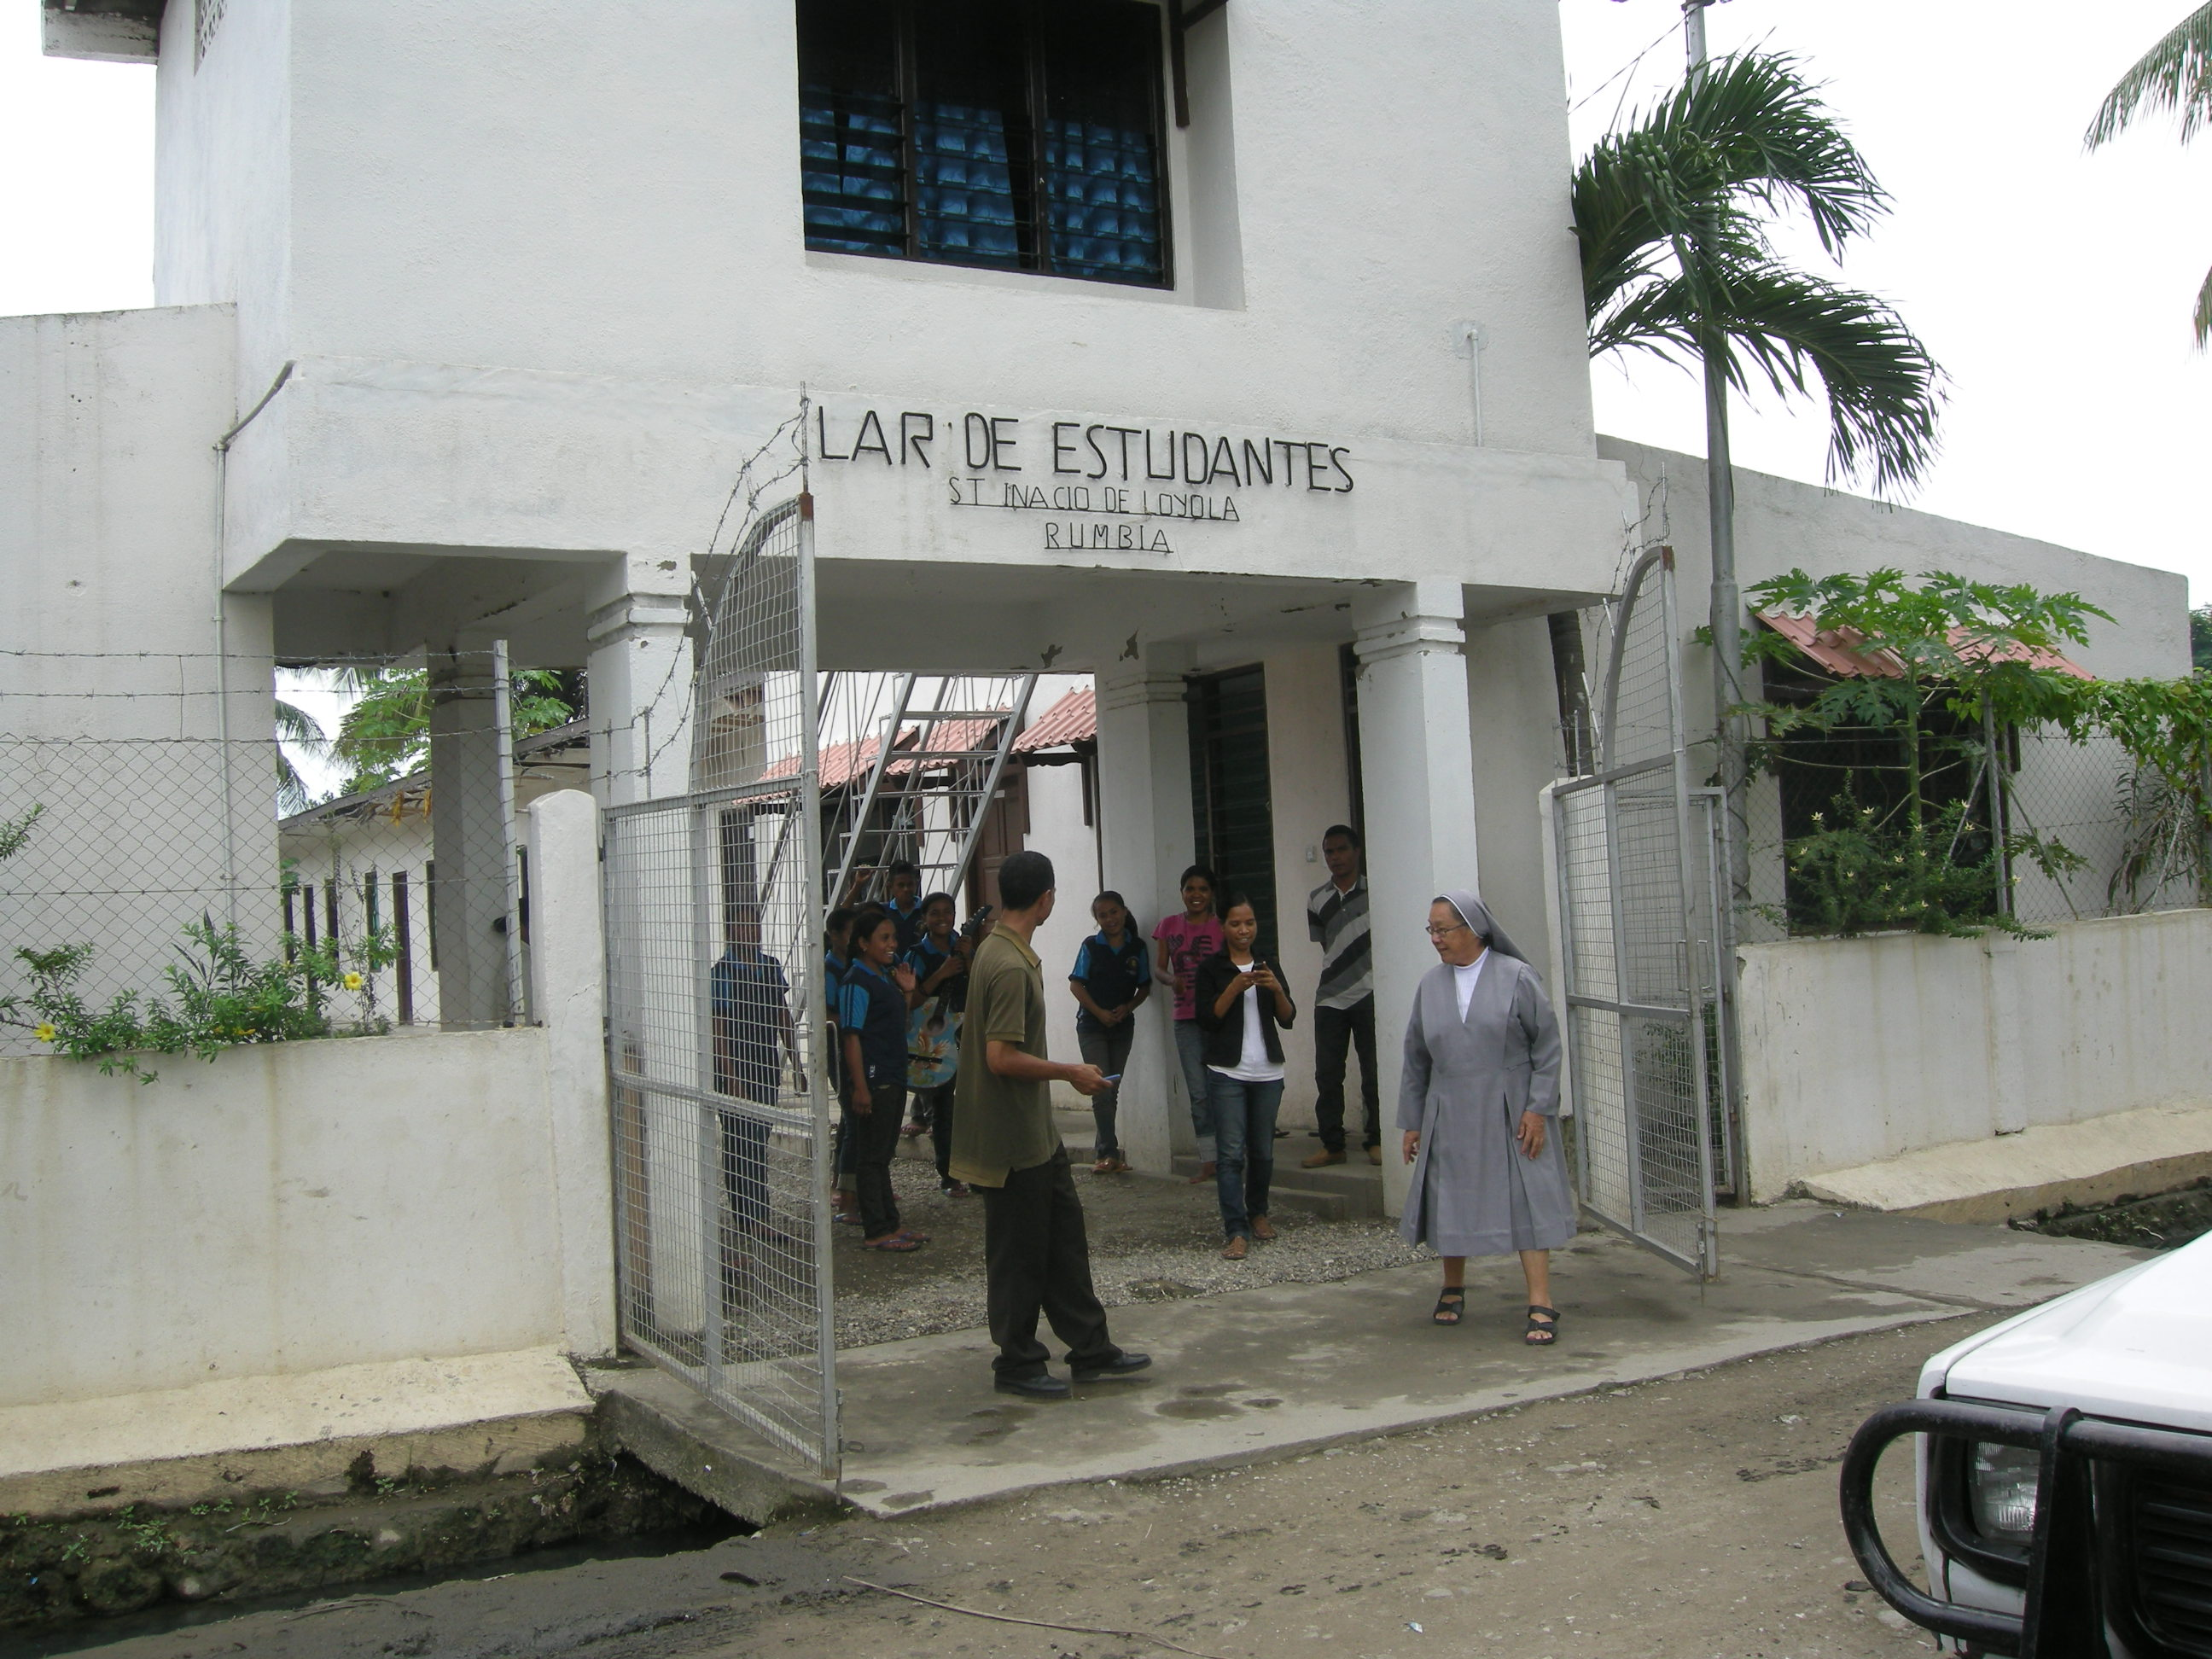

The Peter Trust was able to make a one-off grant of $4800 so that the most urgent work could proceed immediately. Our Secretary met the students in residence who expressed their appreciation and appealed for assistance with further necessary developments.

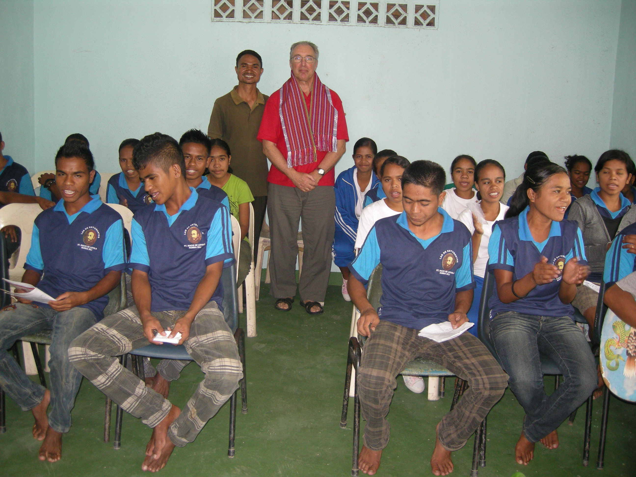

Solar Power to Railaku High School

The Peter Trust funded ($9500) the installation of solar panels at the Parish High School in Railaku, a hill town south of Dili. This provision was effected by the Alternative Technology Association, an Australian NGO based in Melbourne, whose technicians also gave instruction in maintenance and repairs. The school can now operate a computer suite, a sewing room, and provide evening classes to the students and to local people after sunset to the benefit of the community at large.

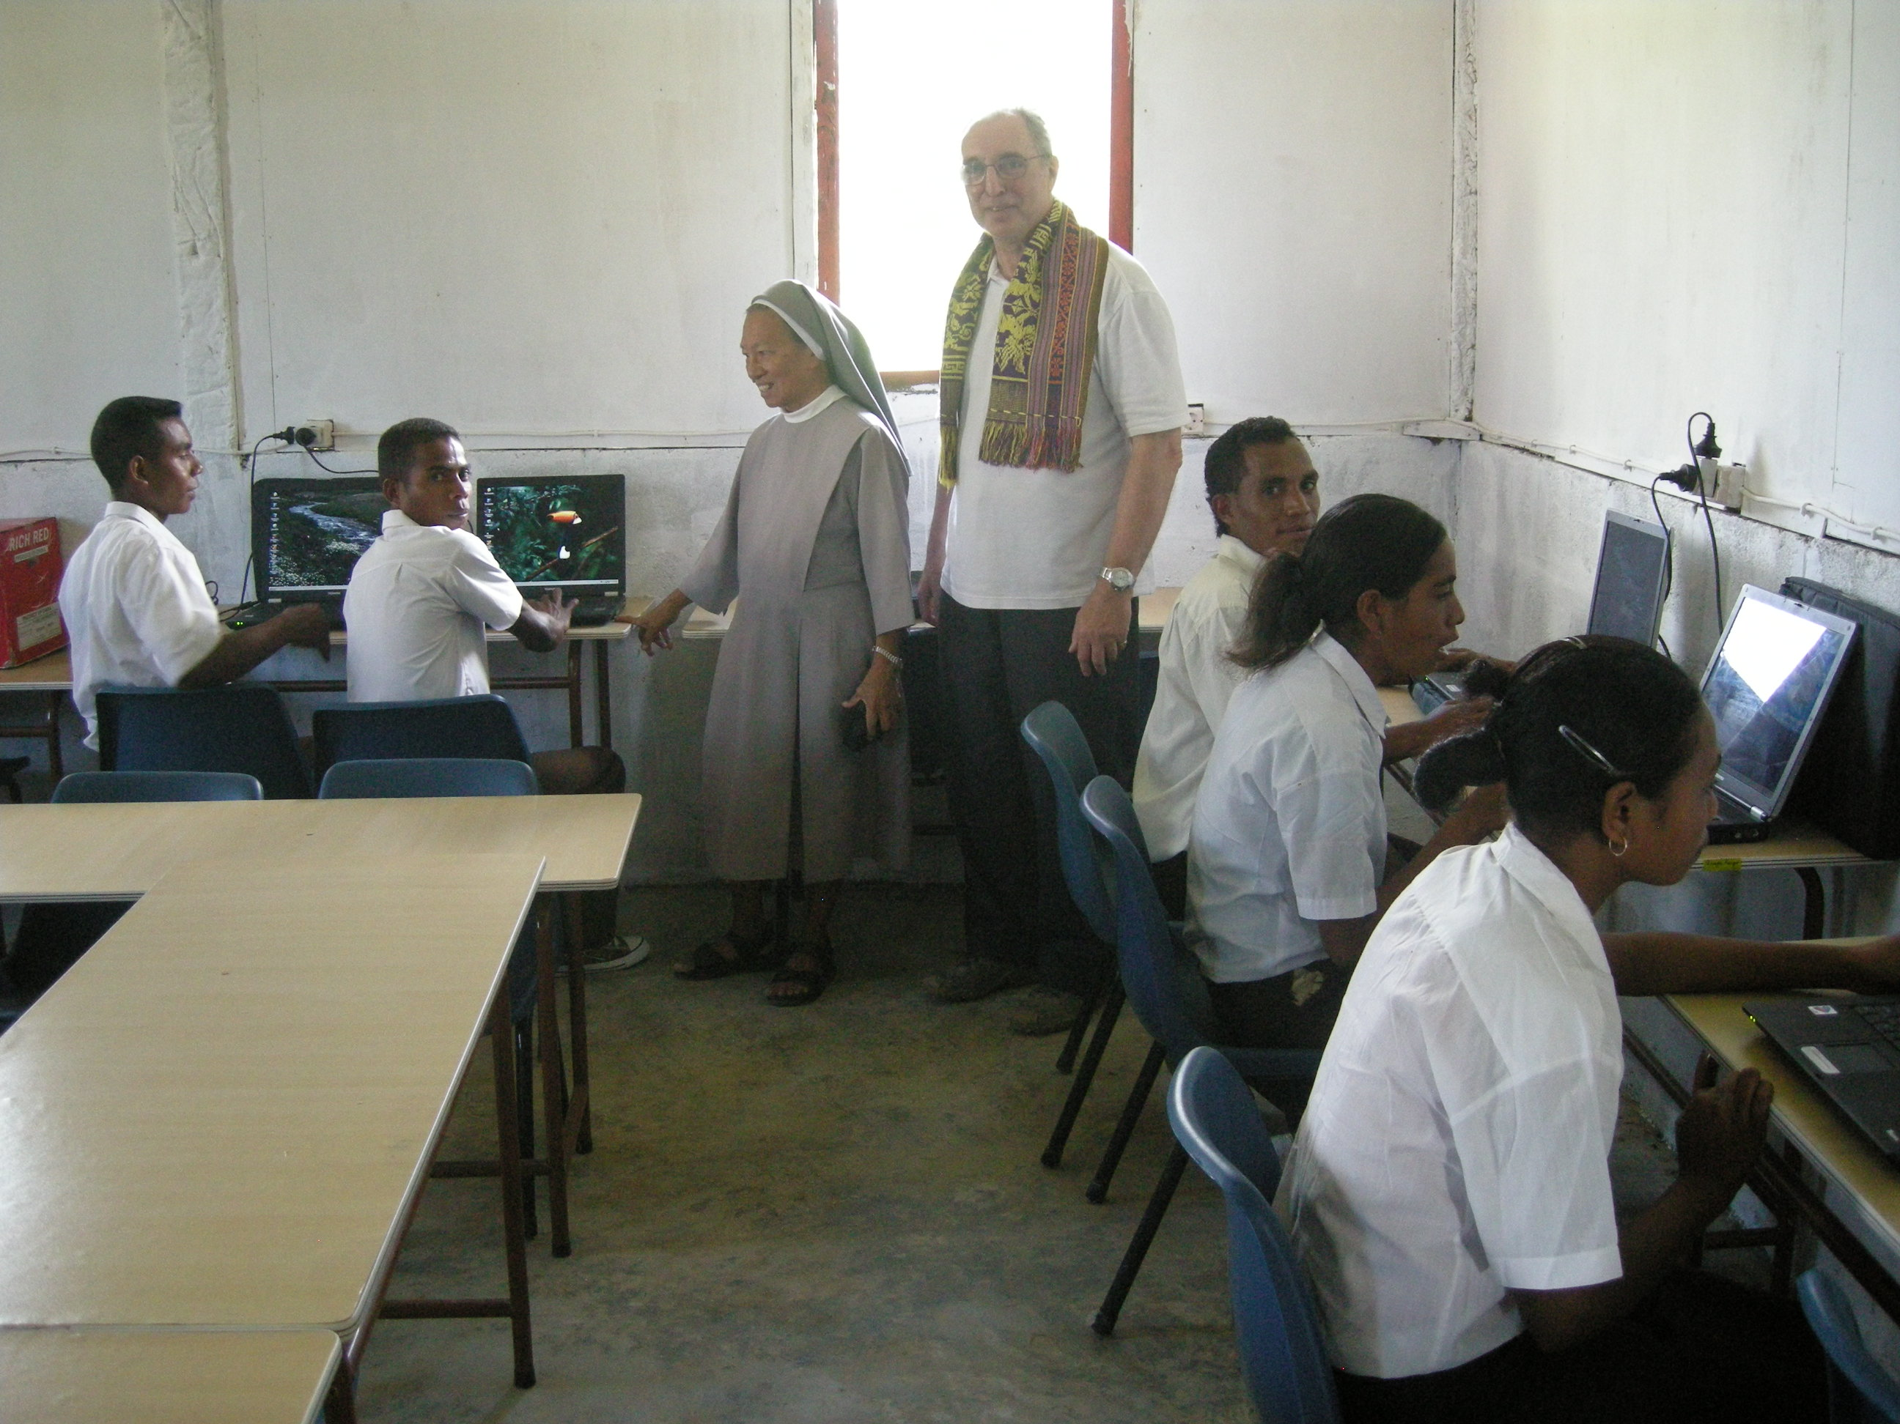

In Railaku the Trust has continued to assist with the secondary education of twenty poor students from the mountains by providing scholarships ($1000 annually).

Boarding House - Baocnana, Oecussi

The enclave of Oecussi is isolated from the rest of Timor Leste and has special needs for that reason. The parish clergy in the seaside village of Baocnana, two hours rough ride from the main port, asked for help to complete the building of an asrama or boarding house for boys and girls from mountain villages so that they can attend high school and also acquire domestic and social skills while in residence. The facilities for 25 girls were provided with the aid of a grant from the Trust and work is now underway to improve the existing accommodation for boys so that the same number can be accepted into the house.

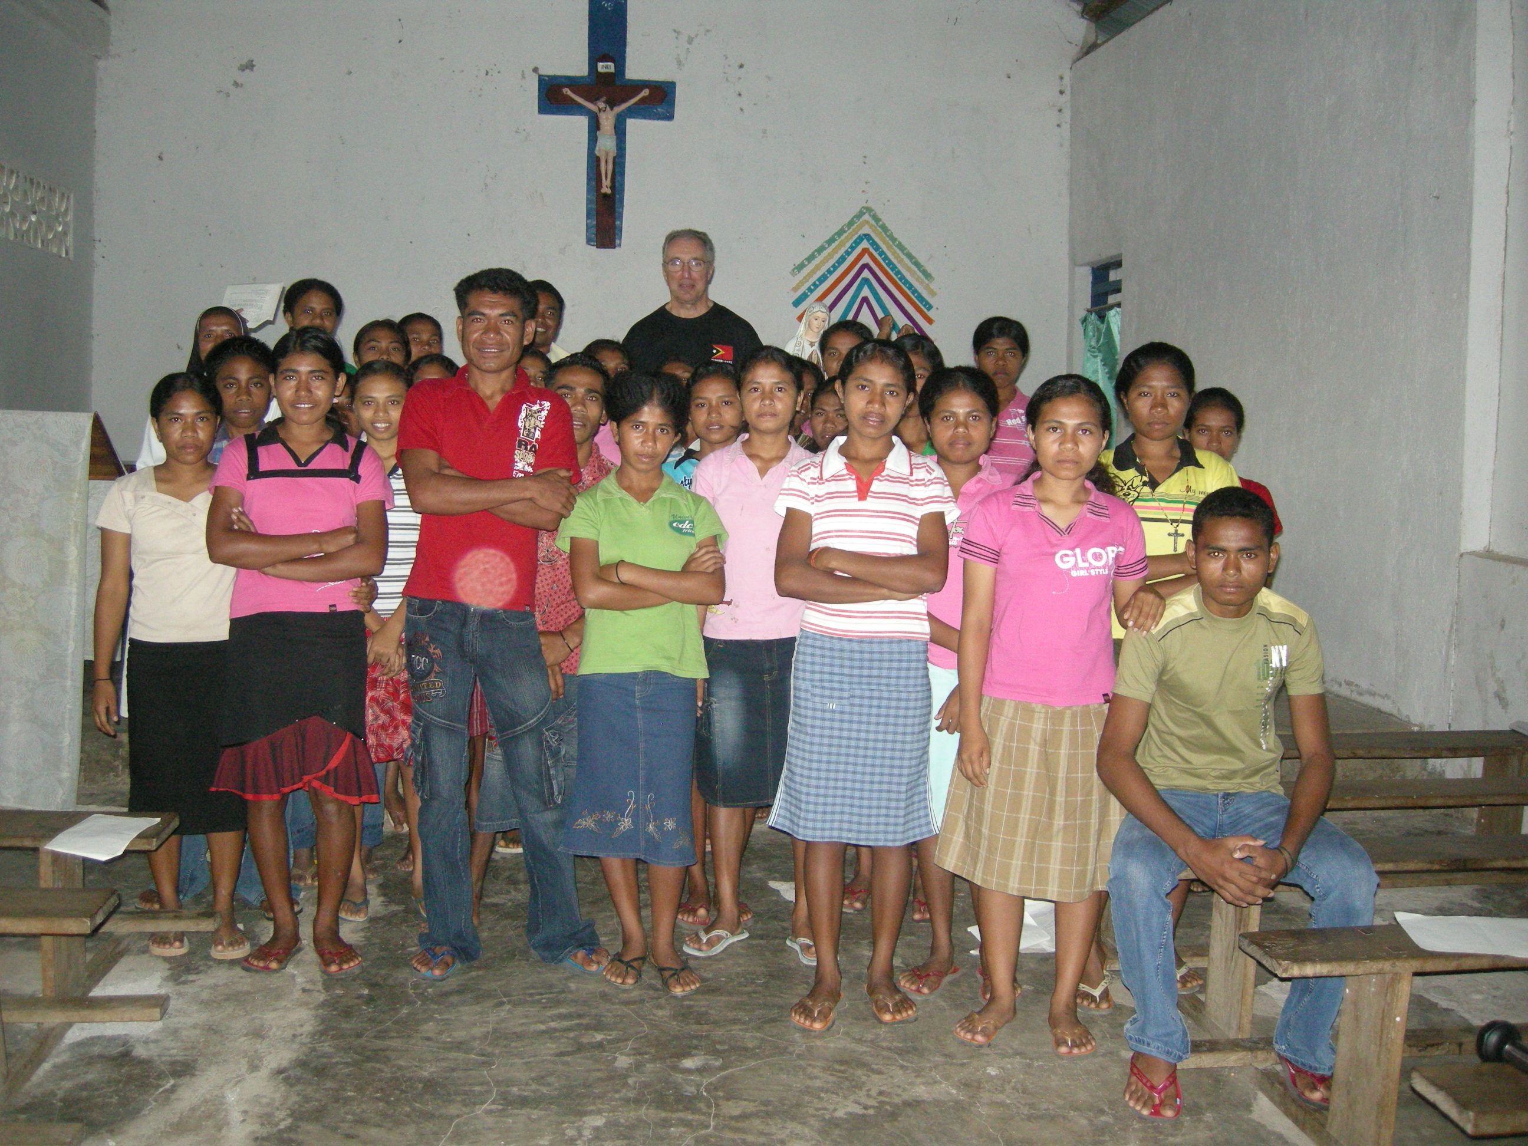

Baocnana hostel residents gather to express thanks to Peter Trust donors.
The residents at the asrama can now also acquire basic computer literacy with the several laptops provided by the Peter Trust ($1500).

Training Facility in Liquica

Fr ‘Zecha’ the Parish Priest in the north coastal township of Liquica to the west of Dili asked for help with the conversion of some outbuildings in the grounds of the presbytery to provide meeting space for local youth and a place for training in leadership and in various practical skills including computing and needlework.

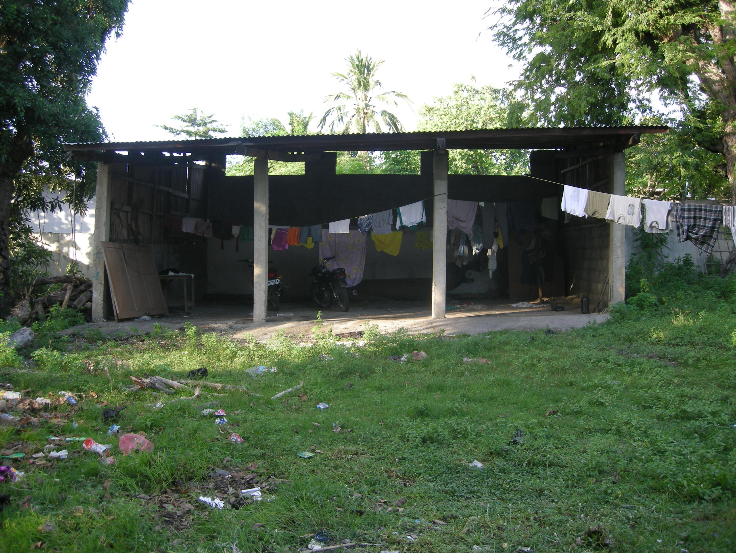

With $2000 initial assistance from the Trust work has been ongoing during the past few months and an update on the adaptation is expected shortly. Overall the project is expected to cost about $4000.

Kuluhun Kraik Youth Project

In facilities provided by the Sisters of St Paul of Chartres adjoining their convent in the Kuluhun Kraik district of Dili the Trust has been supporting young people in the acquisition of language, music, and computing skills along with training in aspects of leadership. Grants of several hundred dollars have provided financial remuneration to the various tutors arranged by the Sisters to instruct local youth. This facility has also done much to alleviate social tensions in this poor neighbourhood of the city which welcomed the arrival of the Sisters and furnished their first simple home there.
Medical Scholarship in Manila

The Dominican Sisters, whose Orphanage in Dili and Orphans Farm in Natarbora in the south is supported by annual grants from the Trust, asked for funds ($4150) to enable a very promising student, Genivia da Silva Marcal from Natarbora, to travel to and be accommodated in Manila (Philippines) and there receive initial training for medical studies. Genivia has now completed her first year which has included the necessary acquisition of a greater command of the English language. Her intention is to return, when qualified, to her local district to help meet the many needs of the local people.
The Trust has also provided funds ($1820) for Sulivan Auxiliadora Kalvia da Silva, a former resident of the OP orphanage in the mountains at Soibada and who is now their driver, to complete a 2 year computer course at Bandung Technical College in Java (Indonesia) - where he previously received his training as a motor mechanic with PT financial support.

Solar Power – Orphanage, Maubara

The Peter Trustees had agreed to support the provision of solar power to a doctor’s surgery at Triloka, a large village in the vicinity of Baucau, Timor Leste’s second largest town. However, the national Government is now making arrangements for mains electricity to reach that locality so in collaboration with ATA (Alternative Technology Association) the promised funding ($3180) plus an extra $2000 ($5000 in total) will be diverted to provide a system for an orphanage at Maubara (located to the west of Liquica on the north coast) where the mains supply is erratic at best and then only functions for a couple of hours after sunset.
The reliable supply of electricity throughout Timor Leste is a priority of the National Government but is years from completion.

Womens Woven Art Workshop

An important project to which the Trustees have given an interim grant (for equipment $4112, and for initial management training - $1200 per month) is the Women’s Woven Art Workshop established by Australian Trisha Johns to enable village women to generate funds to support their families and enhance their dignity in the community. Trisha has applied for ongoing financial support from USAID to enable this project to continue in the long term and is hopeful of a positive outcome to her application which has received official consideration in recent weeks.

Tais are a significant cultural heritage and their creation should be supported on such grounds alone, but the marketing of these items could give real support to women in providing for their families, and enhancing their dignity and status in the community.

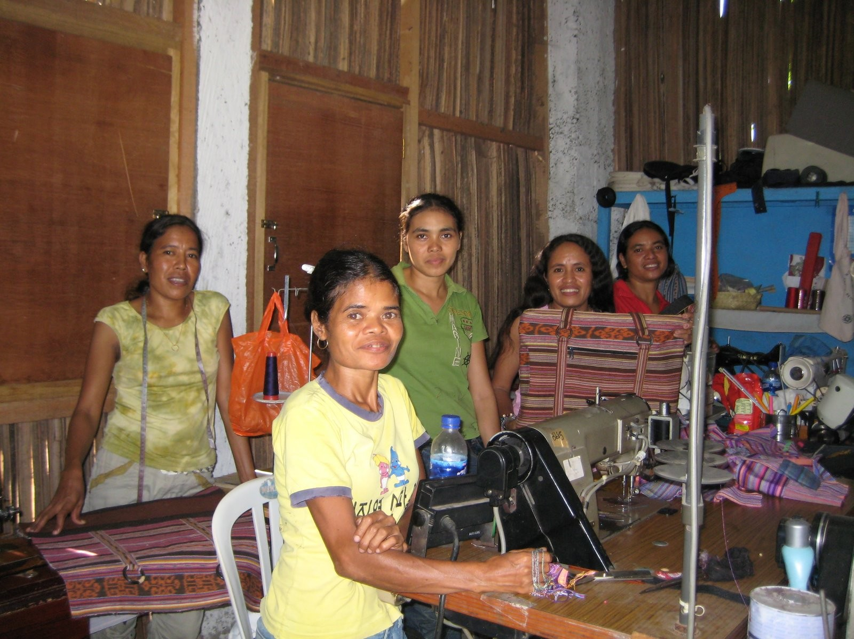

Young women in the Dili Workshop express their appreciation to Peter Trust Donors
____________

Many thanks to all our Friends and Supporters and to all donors whose generosity is enabling an increasing number of projects in health care, education, income generation, technical and leadership training to be established and maintained in East Timor. The need for your assistance continues to be very great: it will be at least a generation before the people of East Timor can develop their country so as to provide adequately for their basic needs – until then all that we can do to help is much appreciated!

Many thanks to all our Friends and Supporters and to all donors whose generosity is enabling an increasing number of projects in health care, education, income generation, technical and leadership training to be established and maintained in East Timor. The need for your assistance continues to be very great: it will be at least a generation before the people of East Timor can develop their country so as to provide adequately for their basic needs – until then all that we can do to help is much appreciated!

